Course: CO2214: Practical work on CO2224

Course: CO2214: Practical work on CO2224

Group Number/Name: Group 06

Student IDs:

EUSL/TC/IS/2021/COM/15

EUSL/TC/IS/2021/COM/18

EUSL/TC/IS/2021/COM/25

EUSL/TC/IS/2021/COM/70

EUSL/TC/IS/2021/COM/102

EUSL/TC/IS/2020/COM/107

**Project Overview**

● **Project Title:** Snapchat

● **Project Type:** Mobile Application

● **Domain:** Social Media & Communication

● **Brief Description:**  
Snapchat is a multimedia messaging app that allows users to send photos, videos, and messages that disappear after being viewed. The app includes features such as Stories, Snap Map, Lenses, Filters, and Bitmoji avatars. Users can also engage in voice and video calls, play games, and explore content from creators and media outlets.

● **The User:**  
Snapchat primarily targets young users, especially teenagers and young adults, who enjoy quick and interactive communication. The platform is widely used for casual messaging, sharing moments, and creative self-expression.

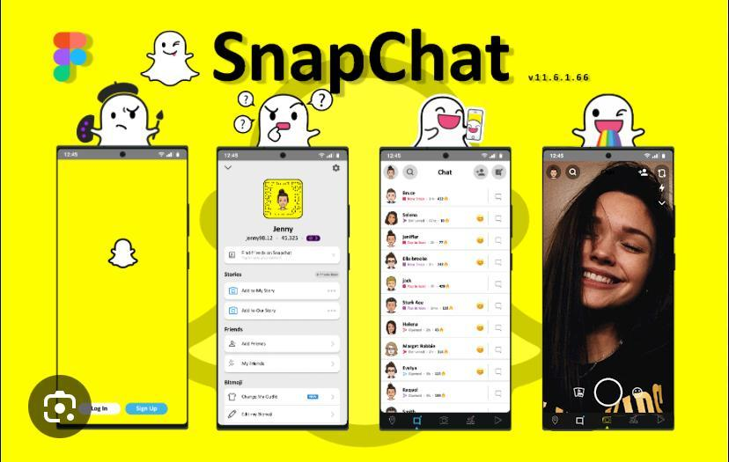

**Identifying Design Flaws & Gaps**

### **1. No Back Button**

**Issue Description:**

* + Users often struggle to return to the previous screen, especially when exploring different features.
  + Many sections of Snapchat lack a visible back button, making navigation confusing.
* **Evaluation Criteria:**
  + *User Control and Freedom*
  + *Consistency and Standards*
* **User Experience Problem:**
  + Confusing navigation flow, especially for new users unfamiliar with gesture-based back actions.
  + Inconsistent with standard mobile app designs, where a back button is expected.
* **Screenshots & Examples:** 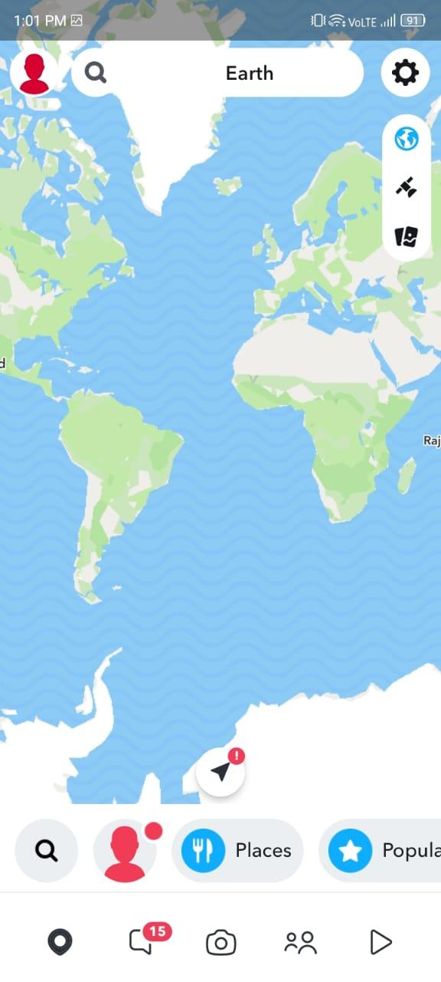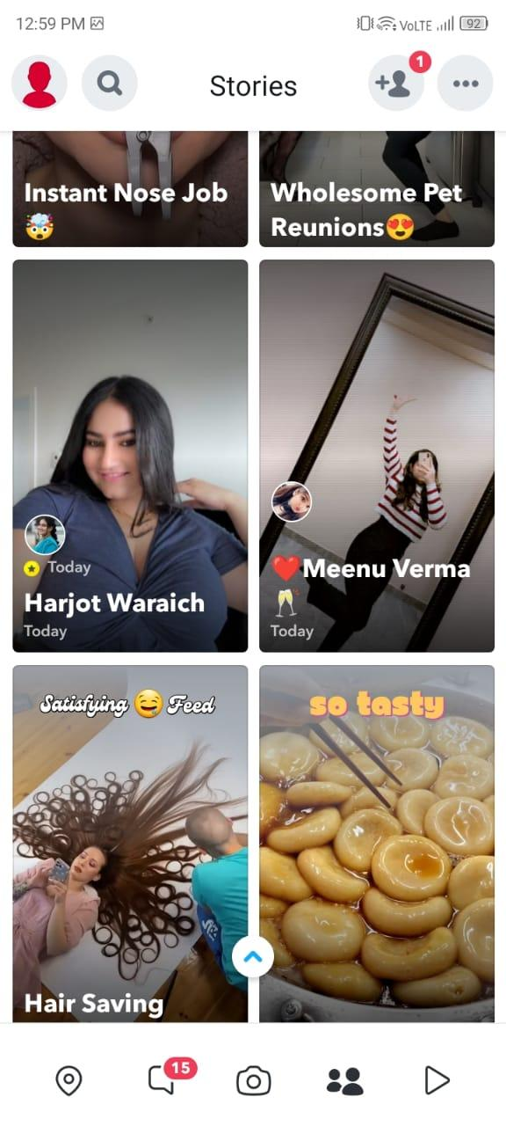

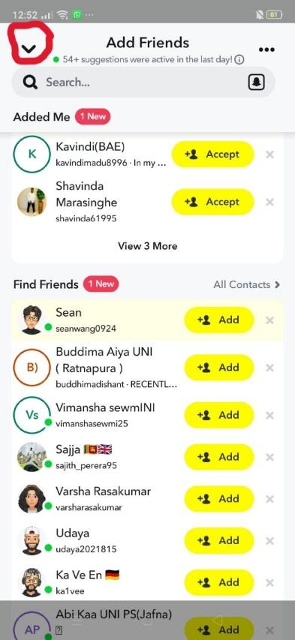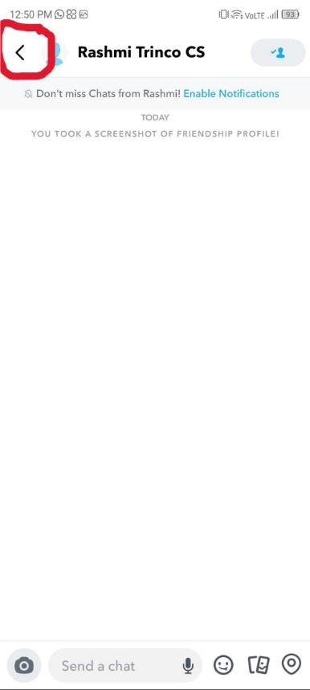

### **2. Unclear Icon Meanings**

* **Issue Description:**
  + Some icons, like the Spotlight (short video) icon, are not labeled.Users cannot easily understand their functions without trial and error.
  + New users may find it difficult to recognize important features without clear labels or tooltips.
* **HCI Principles Violated:**
  + *Learnability*
  + *Feedback and Visibility*
  + *Recognition over Recall*
* **User Experience Problem:**
  + New users may struggle to understand what each icon does.
  + Leads to hesitation or fear of making mistakes.
* **Screenshots & Examples:**



### **3. No Dark Mode Option**

* **Issue Description:**

Snapchat lacks a proper dark mode option for all users, which can cause eye strain, especially in low-light conditions.

A dark mode would improve accessibility and provide a better visual experience.

* **HCI Principles Violated:**
  + *Accessibility*
  + *User Satisfaction*
* **User Experience Problem:**
  + Causes discomfort or eye strain, especially in low-light environments.
  + Decreases usability for visually sensitive users.
* **Screenshots & Examples:** 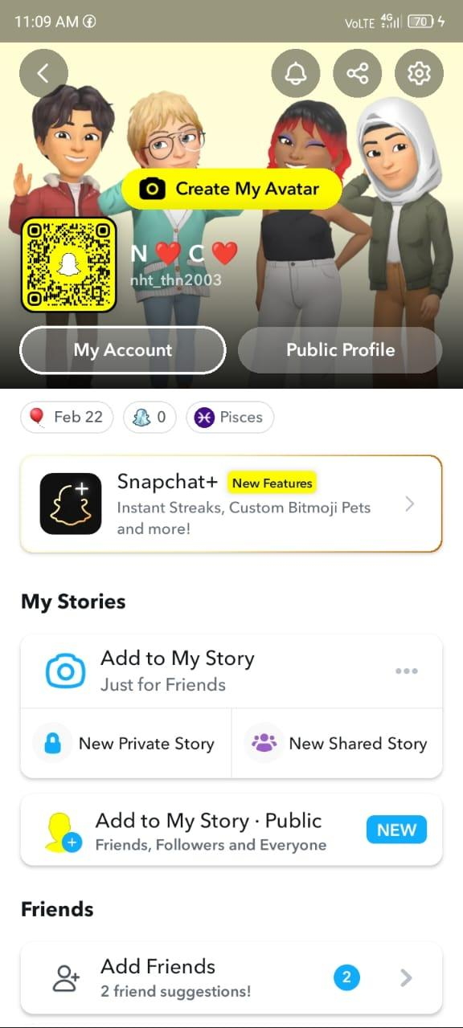

### **4. Difficult for New Users**

* **Issue Description:**
  + The app relies heavily on gestures and swipe actions, which are not always intuitive.First-time users may struggle to navigate the app without proper guidance.
  + A lack of onboarding tutorials makes learning the app more difficult.
* **HCI Principles Violated:**
  + *Learnability*
  + *Help and Documentation*
* **User Experience Problem:**
  + Steep learning curve and frustration among first-time users.
  + Lack of guidance leads to trial-and-error interaction.
* **Screenshots & Examples:**

***The slides that appear when a new user install snapchat***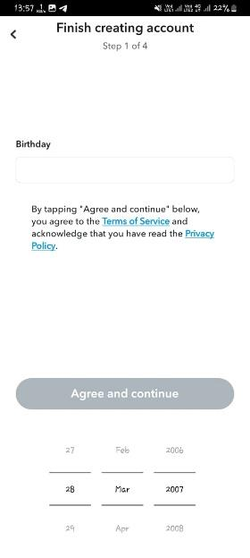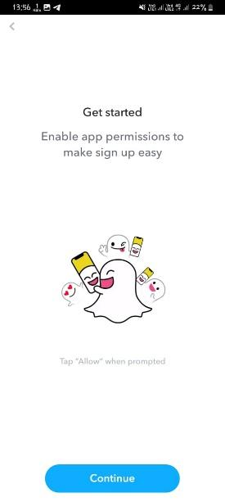

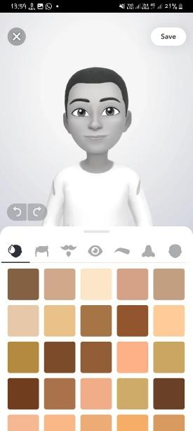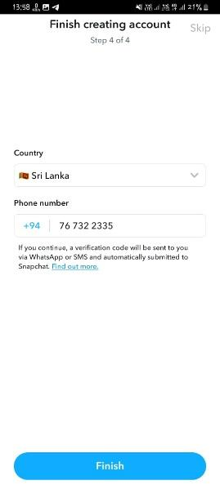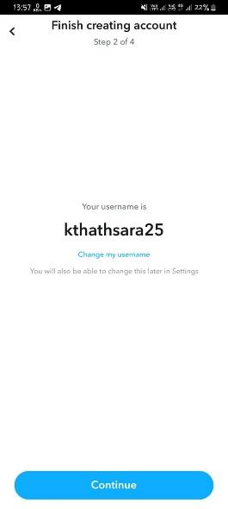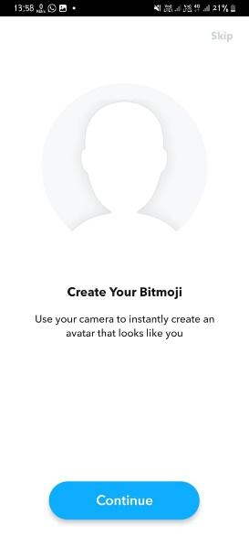

### **5. No Voice Message Preview**

* **Issue Description:**
  + Users cannot listen to a recorded voice message before sending it.If they make a mistake, they must delete and re-record instead of simply reviewing and editing.
* **HCI Principles Violated:**
  + *Error Prevention and Recovery*
  + *User Control and Freedom*
* **User Experience Problem:**
  + Users may send incomplete or flawed messages by mistake.
  + Frustrating to re-record entirely rather than review/edit.
* **Screenshots & Examples:**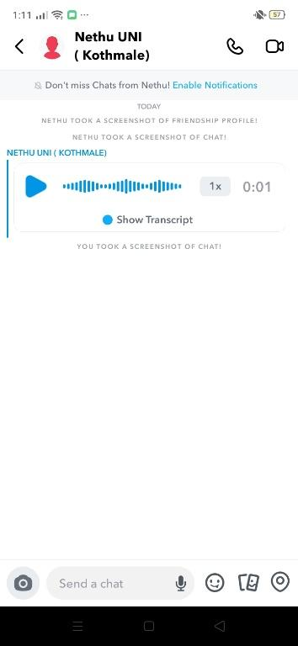

### **6. Camera as the Default Page**

* **Issue Description:**When entering the app, users are immediately taken to the camera page.
  + This can be confusing and overwhelming, especially for new users who may not intend to take a photo right away.
  + A more user-friendly approach would be to show a navigation UI first, allowing users to choose what they want to do.
* **HCI Principles Violated:**
  + User Control and Freedom
  + Task Suitability
* **User Experience Problem:**
  + Confusing or overwhelming for users who just want to chat or view stories.
  + Doesn’t consider user intent on app open.
* **Screenshots & Examples:** 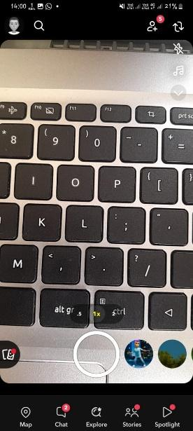

### **7. No Visible Send Icon in Chat**

* **Issue Description:**
  + After typing a message in the chat textbox, there's no visible send icon.
  + Users must press the keyboard's enter key to send, which can be confusing and unintuitive, especially for new users.
  + A clear send button would improve clarity and usability.
* **HCI Principles Violated:**
  + *Feedback and Visibility*
  + *Consistency and Standards*
* **User Experience Problem:**
  + Confuses users accustomed to tapping a send button.
  + Especially problematic for new or less tech-savvy users.
* **Screenshots & Examples:**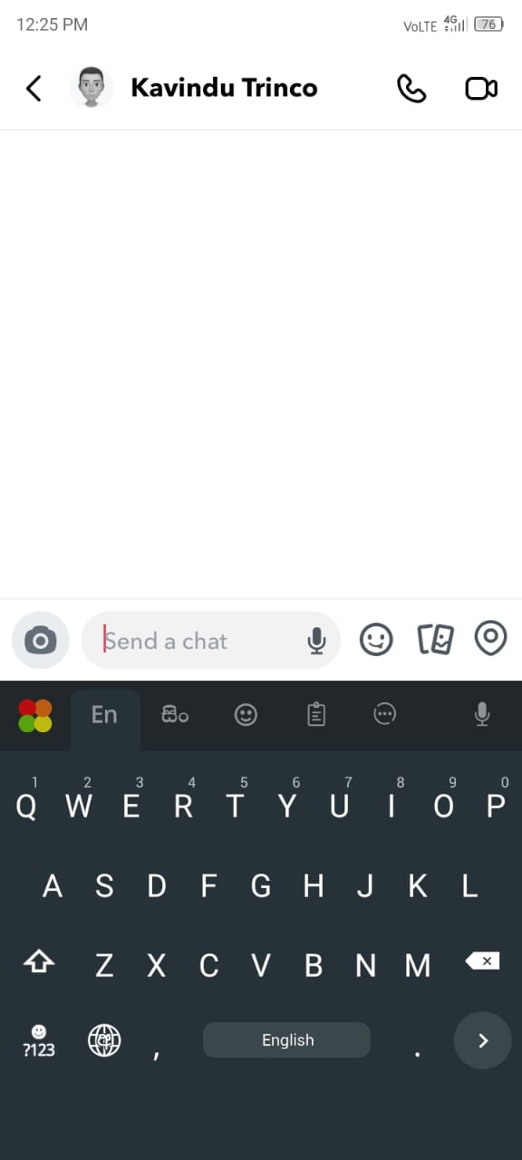

## **Data Gathering and Analysis**

To support our redesign decisions for Snapchat, we collected user feedback through a Google Form survey titled “Snapchat Redesign Feedback Survey.” The goal was to identify real user pain points and feature expectations based on the usability and HCI issues we analyzed earlier.

📄 **Google Form Link:**  
https://docs.google.com/forms/d/e/1FAIpQLSe6YIT9jBmjfd-PzoFq2fHYVcpOac2jYOEnPphIZ_Q_-15dSg/viewform?usp=header

### **Survey Highlights & Key Findings *(Based on Survey Responses)***

* Camera as Default Page:  
   78% of users found it confusing or preferred a menu screen instead. This strongly supports the redesign choice to implement a navigation landing page.
* Lack of Send Icon in Chat:  
   82% of users said the absence of a visible send button was confusing. This validated the addition of a send icon next to the message box.
* Tooltips and Labels for Icons:  
   86% of users, especially first-time users, agreed that tooltips or labeled icons would improve clarity. This led to the design of blue onboarding tooltips with “Next” and “Cancel” options.
* Dark Mode Preference:  
   Over 90% of participants preferred a dedicated dark mode, which influenced our decision to add a theme toggle in the Settings page.
* Voice Message Preview:  
   74% of users expressed the need for a preview option before sending voice messages. Our redesign now includes preview, delete, and send options, along with voice effects for personalization.

### 

The feedback gathered from the survey responses strongly supported all proposed redesign features. Every major design decision—from adding tooltips to reworking navigation—was directly informed by real user preferences. This approach ensured our redesign stayed grounded in actual user needs and HCI best practices.

**HCI-Based Design Improvement Suggestions**

### **1. Introduce a Visible Back Button**

* **Proposed Improvement**:  
   Incorporate a clearly visible back button across all navigable sections within the app.
* **HCI Principle(s) Applied**:
  + *User Control and Freedom*: Allows users to undo actions and return to previous screens.
  + *Consistency and Standards*: Conforms to common design conventions familiar to users.
* **Interaction Improvement**:  
   Enhances navigation and reduces confusion by enabling users to move backward without relying on gestures or device-specific buttons, particularly benefiting new or infrequent users.

### **2. Label Icons or Provide Tooltips**

* **Proposed Improvement**:  
   Add descriptive labels for icons and add tooltips for new users ambiguous functions.
* **HCI Principle(s) Applied**:  
  + *Recognition Rather Than Recall*: Helps users identify functionality without needing to remember icon meanings.
  + *Visibility of System Status*: Keeps users informed about what an icon represents.
* **Interaction Improvement**:  
   Improves usability by making functions self-explanatory, thereby reducing the cognitive load and avoiding errors due to misinterpretation of icons.

### **3. Implement a Navigation Menu as the Default Page**

* **Proposed Improvement**:  
   Replace the default camera screen with a structured navigation page that allows users to choose where to go (e.g., Chat, Stories, Camera, Spotlight, etc.).
* **HCI Principle(s) Applied**:  
  + *Flexibility and Efficiency of Use*: Offers users control over their starting point based on intent.
  + *Match Between System and Real World*: Reflects the typical expectation that users first see a menu or dashboard.
* **Interaction Improvement**:  
   Reduces user confusion and task abandonment by allowing them to consciously select their preferred action instead of being forced into using the camera.

### **4. Add a Visible Send Icon in Chat**

* **Proposed Improvement**:  
   Introduce a visible "Send" icon beside the text input field in chat interfaces.
* **HCI Principle(s) Applied**:  
  + *Affordance*: Clearly indicates how to perform the send action.
  + *Error Prevention*: Reduces the chance of users pressing the wrong key or being unsure how to send messages.
* **Interaction Improvement**:  
   Makes the chat experience more intuitive, especially for users unfamiliar with using the Enter key to send messages. It also standardizes messaging interactions similar to other chat apps.

### **5. Introduce a Voice Message Preview Feature**

* **Proposed Improvement**:  
   Add an option for users to preview recorded voice messages before sending them.
* **HCI Principle(s) Applied**:  
  + *Error Prevention and Recovery*: Allows users to review content before committing.
  + *User Control and Freedom*: Empowers users to discard or re-record voice messages if unsatisfied.
* **Interaction Improvement**:  
   Increases user confidence and satisfaction by reducing the risk of sending unwanted or incomplete voice messages.

### **6. Add a Dedicated Dark Mode Option**

* **Proposed Improvement**:  
   Implement a feature for switching between light and dark themes within settings.
* **HCI Principle(s) Applied**:  
  + *Accessibility*: Supports visual comfort for all users, particularly in low-light environments.
  + *User Satisfaction*: Provides personalization options and reduces strain during prolonged use.
* **Interaction Improvement**:  
   Enhances readability and comfort, especially during nighttime usage, which is common among Snapchat’s user demographic.

### **Redesigned Prototype**

### **1. Introduce a Visible Back Button**

**Overview of the New Design:** A visible back button is added to all major screens (e.g., Camera, Chat, Snapmap, Stories, Spotlight) to enhance navigation. This aligns with HCI principles like User Control and Freedom, Consistency, and Error Prevention, making the app easier to use.

**Wireframes & Mockups:** Screens redesigned in Figma include a back button at the top-left. It blends with Snapchat’s UI style and offers consistent navigation.

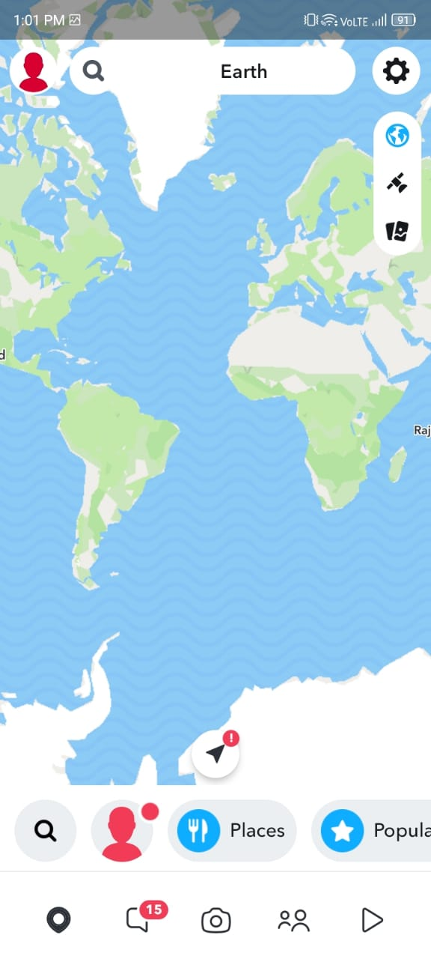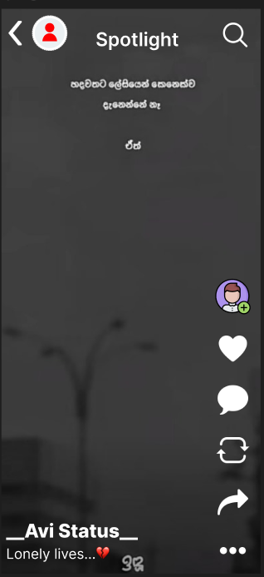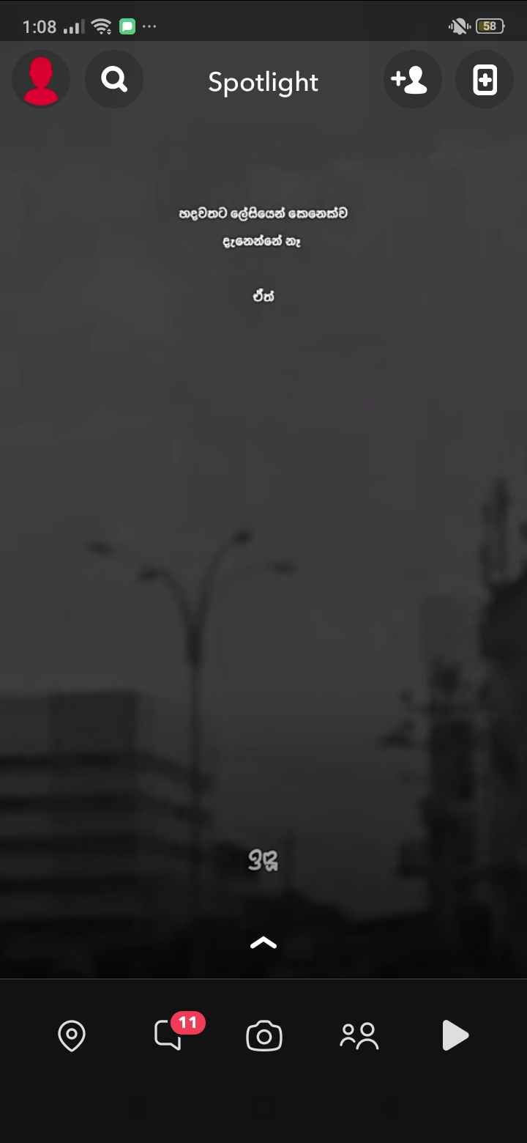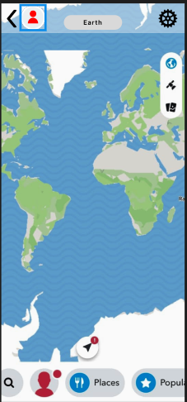



**User Flow Diagram:**

Home → Profile/Chat/Camera → *(Tap Back)* → Returns to Home or Default Page.

**Prototyping Features Used in Figma:**

* Back button as a component reused across screens.
* "On Click → Navigate To" interaction added.
* Smart animations for smooth transitions.

### **2. Label Icons or Provide Tooltips**

### **Overview of the New Design:**

To support new users, blue tooltip boxes were added to highlight unclear icons and features. These tooltips offer “Next” and “Cancel” options for guided navigation. This redesign improves icon clarity and onboarding using HCI principles like *Recognition Rather Than Recall* and *Help and Documentation*.

**Wireframes & Mockups:**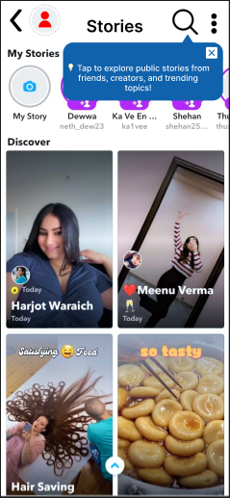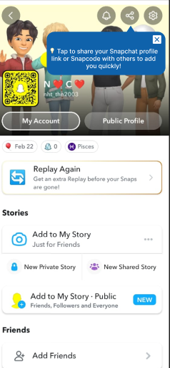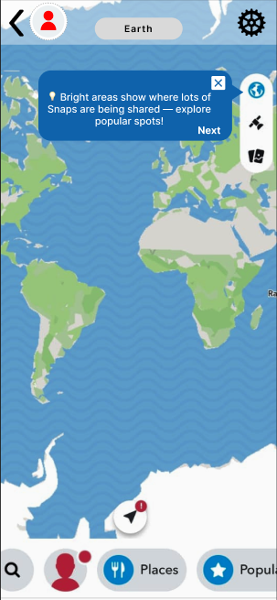

**User Flow Diagram:**

Home → Icons with Tooltips → Tooltip Explains Feature → (User taps “Next” or “Cancel”) → Informed Action → Smoother Navigation

**Prototyping Features Used in Figma:**

* **Blue tooltips** added as overlay components beside unfamiliar icons.
* **Interactive buttons** (Next / Cancel) created using component variants.
* Used **Prototype flows** in Figma to simulate tooltip walkthrough per screen.
* Tooltips appear only for **first-time users** or on-demand, improving learnability without overwhelming frequent users.

**3. Implement a Navigation Menu as the Default Page**

**Overview of the New Design:** The new design introduces a **default landing page** that displays a clean navigation interface combining **Friends’ Stories** and a **menu bar**. Users land on this screen instead of being directly thrown into the camera. This design aligns with the following HCI principles:

* **User Control and Freedom** – Empowers users to decide where to go (e.g., Chat, Camera, Stories).
* **Recognition Rather Than Recall** – Uses labeled icons and visual elements to guide users.
* **Consistency and Standards** – Follows familiar app layout patterns with stories at the top and a consistent bottom menu.

**Wireframes & Mockups:** 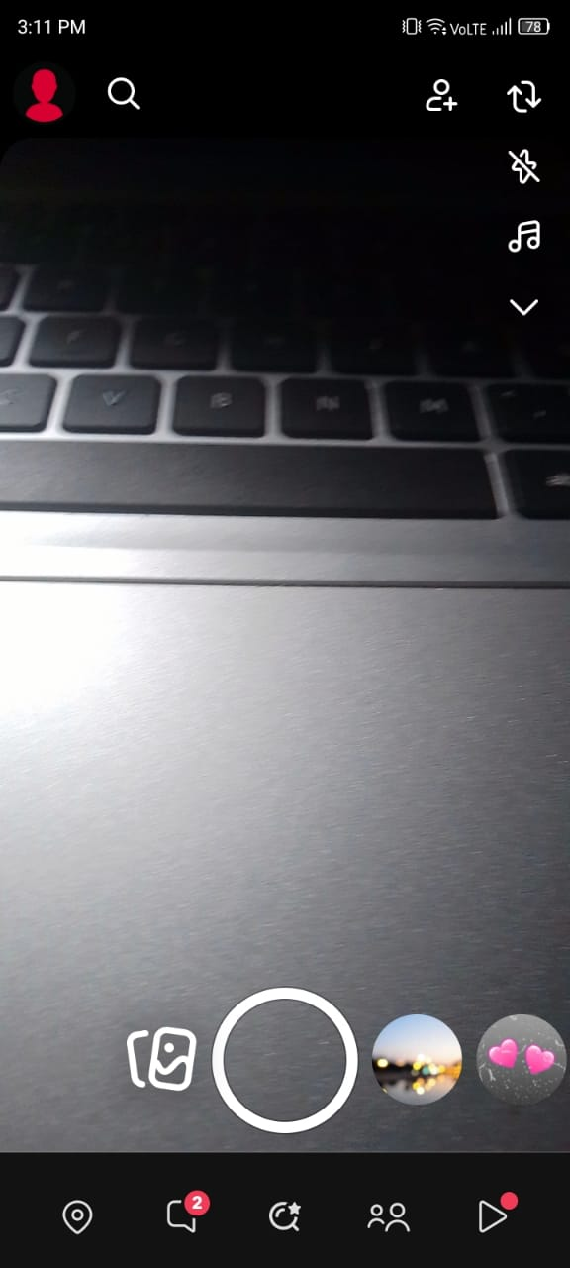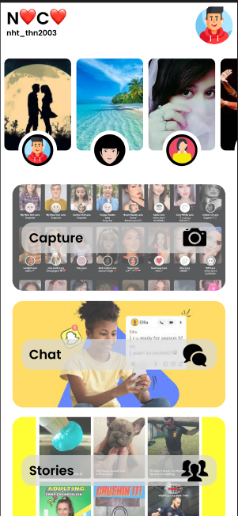



* The top section displays horizontally scrollable Friends’ Stories.
* The main area supports vertical scrolling for sections like Discover or suggested content.
* A persistent bottom menu includes icons for:  
  + Camera
  + Spotlight
  + Stories
  + Chat
  + Snap Map
  + Memories

**User Flow Diagram:** Launch App → Default Page (Stories + Menu) → Tap on Menu Option (e.g., Chat) → Navigate to Selected Screen → (Tap Back) → Return to Default Page

**Prototyping Features Used in Figma:**

* **Scrolling Frames:** Implemented **horizontal scroll** for stories and **vertical scroll** for content browsing.
* **Interactive Components:** Each menu icon is interactive, navigating to its corresponding screen.
* **Animated Transitions:** Smooth sliding animations applied when moving between screens.
* **Variants:** Used for story previews, highlighting active/inactive states.

**4. Add a Visible Send Icon in Chat**

**Overview of the New Design:** The redesign introduces a **clearly visible send icon** next to the chat text bar. This icon replaces the need to press the "Enter" key, aligning the design with standard mobile app behavior. It improves usability and supports the following HCI principles:

* **Visibility of System Status** – Users can clearly see when a message is ready to be sent.
* **Affordance** – A send icon provides a visual cue that the element is tappable and will send the message.
* **User Control and Freedom** – Allows users to send messages intentionally rather than accidentally.

**Wireframes & Mockups:** 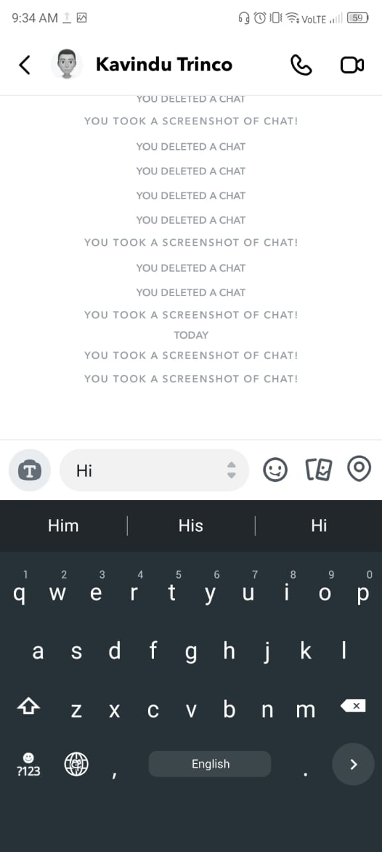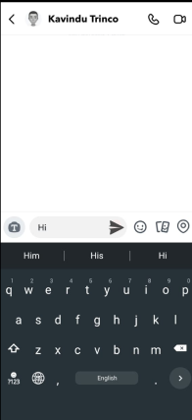



* The chat screen now includes a **send icon (paper plane)** at the right end of the message input field.

**User Flow Diagram:** Open Chat → Type Message → Tap Send Icon → Message Sent → Remains on Chat Screen

**Prototyping Features Used in Figma:**

* **Interactive Component**: Created an interactive **send icon button** that reacts when tapped.
* **Variants**: Used icon states (inactive when no text, active when typing).
* **Auto Layout**: Ensures consistent spacing between the input box and the send icon on different screen sizes.
* **Transitions**: Added micro-interactions for smooth feedback when the send button is pressed.

**5. Introduce a Voice Message Preview Feature**

**Overview of the New Design:** The redesign adds a **voice message preview** feature that allows users to **listen to their recorded voice message** before sending. This follows HCI principles by helping users avoid errors and feel in control. A new **voice effect option** is also integrated for personalization and improved engagement.

**HCI Principles Applied:**

* **Error Prevention** – Users can detect and correct mistakes before sending.
* **User Control and Freedom** – Enables discarding or re-recording messages.
* **Flexibility and Efficiency of Use** – Advanced users can quickly review, apply effects, and send.

**Wireframes & Mockups:** 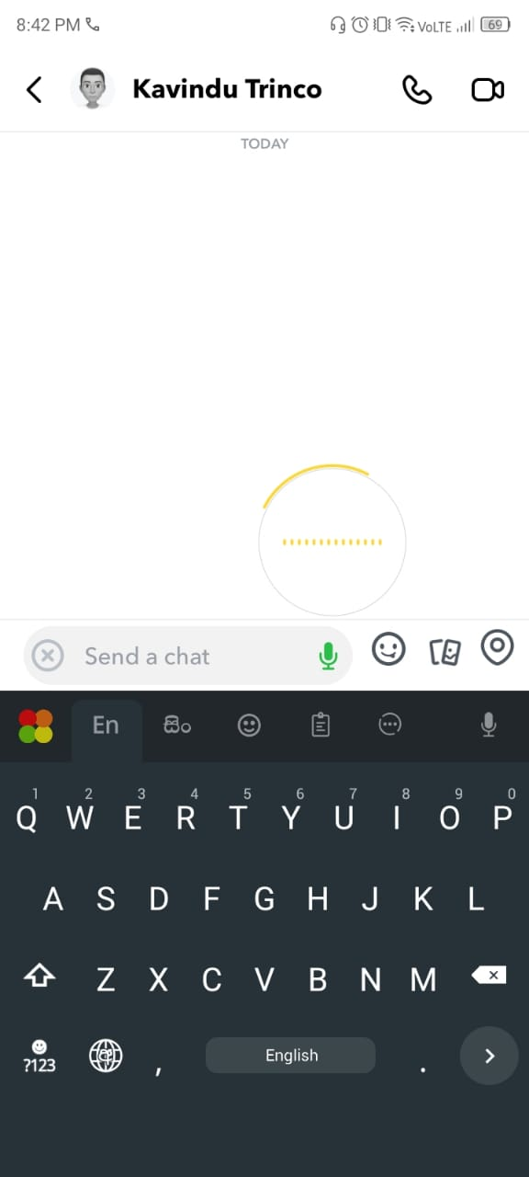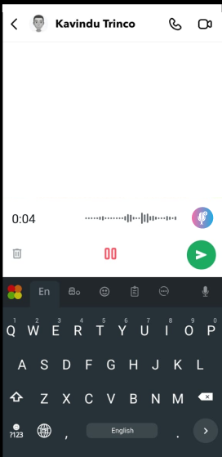



* Voice message UI now includes **Play**, **Delete**, and **Send** buttons after recording.
* A **voice effects panel** (e.g., helium, echo, robot) is accessible via a small icon before sending.

**User Flow Diagram:** Hold to Record → Stop Recording → Preview Screen → (Play / Apply Effect / Re-record / Send) → Message Sent

**Prototyping Features Used in Figma:**

* **Interactive Components**: Play/pause toggle, send, delete, and voice effect options built as clickable elements.
* **Component Variants**: Voice message bubble updates to preview mode after recording.
* **Overlay Effect Panel**: Slide-up panel interaction for choosing a voice effect.
* **Transitions**: Smooth micro-animations between record, preview, and send states for natural flow.

**6. Add a Dedicated Dark Mode Option**

**Overview of the New Design:** The redesign introduces a **dedicated Dark Mode toggle** in the **Settings** section. This change aligns with HCI guidelines by enhancing **aesthetic and minimalist design**, improving **accessibility**, and reducing **visual fatigue**, especially in low-light environments.

**HCI Principles Applied:**

* **Aesthetic and Minimalist Design** – Offers a cleaner interface with comfortable contrast.
* **Accessibility** – Supports users with visual sensitivity and those using the app at night.
* **User Control and Freedom** – Empowers users to choose between light and dark interfaces.

**Wireframes & Mockups:** 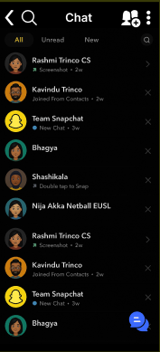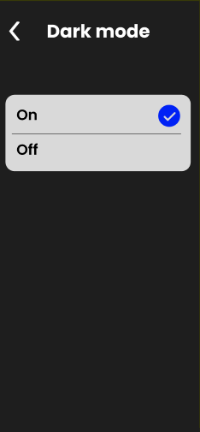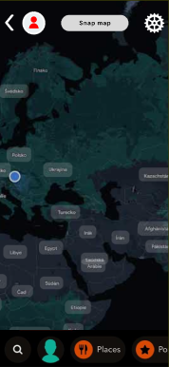

* A new **Dark Mode toggle** is added in the Settings screen.
* UI screens are fully redesigned in a **dark color palette**: backgrounds in deep gray/black and text/icons in white or accent colors for contrast.

**User Flow Diagram:** Home → Settings → Toggle Dark Mode → App Theme Switches Instantly

**Prototyping Features Used in Figma:**

* **Component Variants**: All screens have light and dark theme versions.
* **Toggle Switch Interaction**: Clicking the Dark Mode switch transitions between themes.
* **Smooth Transitions**: Fade effect applied between light and dark mode for better UX.
* **Reusable Styles**: Color tokens are used to maintain consistency across all screens in both modes.

## **Conclusion**

### **Final Thoughts on the Redesign**

Through detailed evaluation, user feedback, and HCI-based redesign, we addressed several usability flaws in Snapchat such as the missing back button, lack of tooltips, and absence of a dark mode. Our redesign introduces a more intuitive navigation structure, better visual clarity, improved messaging controls, and accessibility enhancements. These improvements aim to make Snapchat easier and more enjoyable for both new and experienced users.

### **How HCI Theory Helped**

We applied key principles from **Alan Dix’s HCI model** and **Preece-Rogers-Sharp’s Interaction Design (ID)** framework to guide our analysis and design. Concepts like **User Control and Freedom**, **Error Prevention**, **Recognition Rather Than Recall**, and **Feedback & Visibility** helped us identify real-world usability issues and translate them into practical design solutions. These theories provided a structured way to evaluate the app's existing flaws and justify our redesign decisions.

### **Lessons Learned**

This project helped us understand the importance of **user-centered design** and how small usability improvements can greatly enhance the overall experience. We learned how to collect and analyze real user data, create low-fidelity prototypes, apply interaction design theories, and use tools like **Figma** for realistic design simulation. Most importantly, we realized that good design is not just about aesthetics but about making technology **more usable, accessible, and satisfying** for everyone.

## **References**

* Snapchat official website –<https://www.snapchat.com>
* User reviews and feedback from the **Google Play Store**
* YouTube videos demonstrating Snapchat UI and feature walkthroughs
* Images and UI design ideas gathered from **Google Search**
* HCI concepts referred from Alan Dix's and Preece-Rogers-Sharp's books and lecture notes